**BOAT PROJECT**

**MEC DOMAIN**

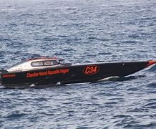

**ACTION PLAN**

**Introduction**

1. **A brief study of the boat propulsion**
2. **System functional analysis and component selection**
3. System functional analysis
4. Functional workbook
5. Selection criteria
6. Solution matrix
7. **Study of the power transmission system**
8. Study of the system
9. Study of the stretch exerted on the system
10. **Dimensional sizing**
11. Transmission line sizing
12. propeller sizing
13. Sealing solutions.
14. **Reinforcement and boat thickness**
15. **CAD**
16. Component CAD
17. Hull CAD integration

**Conclusion**

1. **A BRIEF STUDY OF BOAT PROPULSION**
2. **Definition and objectives**

In shipbuilding, **impetus** **alludes** to all the **frameworks** that **empower** ships and **vessels** to move. **Drive** is **given** by an engine-driven thruster.

The objectives of propulsion are:

Giving propulsive pushed with the most elevated conceivable effectiveness. Drive productivity depends on the vitality productivity of the engine, the mechanical productivity of the transmission and the hydrodynamic effectiveness of the thruster.

* Giving propulsive pushed with the most elevated conceivable effectiveness. Drive productivity depends on the vitality productivity of the engine, the mechanical productivity of the transmission and the hydrodynamic effectiveness of the thruster.
* Work securely in a wide run of conditions: cruising speed, moderate speed, antagonistic climate conditions (harsh oceans), completely stacked or in balance.
* Guaranteeing manoeuvrability on the move, either specifically (vector pushed) or through one or more rudders.
* Empower, in certain cases, manoeuvring at stop and at moo speed (differential impact, impact on rudder(s))

Four main functions can be distinguished in any motorized propulsion system:

* On-board vitality capacity (battery);
* The change of accessible vitality into mechanical vitality by an engine;
* Transmission of this vitality to the thruster (control transmission unit);
* The change of this vitality into a driving constrains by the propeller.

#### **Boat speed**

Within the case of the electric watercraft, the most motor acts as a power generator, and the propeller shaft is driven by this electric engine.

The propeller is the foremost commonly utilized propeller and is as a rule found at the strict of the transport. It pivots around a level or somewhat slanted pivot. The "entire speed" of the edges produces a pushed that drives the dispatch forward.

A transport, like everybody moving in a liquid, is subject to a constrain that restricts its development; to overcome this "resistance to forward movement", it must subsequently be provided with a certain sum of vitality. This vitality may come from exterior, from the wind on the sails, or from another towing or pushing vehicle, but it is most frequently provided by the vessel's possess engine, or by the electric engine for an independent pontoon. The drive framework hence comprises: downstream, the propeller, which generates thrust against resistance;

* Upstream, a prime mover, whose part is to convert the vitality within the battery into mechanical vitality, conceivably after passing through electrical vitality;
* Between the two, components planned to adjust and transmit the mechanical control hence delivered to the propeller.

Choosing which thruster (or thrusters) to introduce on a given vessel isn't a supreme choice. In rule, it's a matter of finding the leading compromise between the three major components:  
body, motor and thruster. Be that as it may, as the most characteristics of the body are more or less settled at the beginning of the extend, and those of the motor a short time later, the necessary adaptation of body, motor and impetus unit is in fact a matter of attempting to discover the impetus unit that leads to the leading by and large proficiency, either at a given speed of the vessel, or at a given number of engine revolutions, or by regarding an forced esteem for another parameter. Additionally, this choice must regard certain geometric imperatives (most extreme conceivable breadth, etc.), and take into consideration quality criteria other than productivity, such as the nonattendance of cavitation or exasperating vibrations.

1. **SYSTEM FUNCTIONAL SYSTEM AND COMPONENT SELECTION**
2. **Functional analysis**
3. Horned Beast Diagram.

The Horned Beast diagram will help us answer the three key questions about our propulsion system: who does it serve, what does it work on, and for what purpose was it created? By constructing this diagram, we will be able to visualize the relationships between the different parts of the boat and understand its overall functioning.

Propel the boat on water.

who does it serve?

what does it work on?

For what purpose was it created?

**Horned beast diagram,**

1. Octopus diagram.

The Octopus diagram allow us to identify the main functions, the constrained functions and the service functions of the product. These functions are essential to ensure its performance, security and overall functionality. By identifying the interactions between the boat and its environment, we will be able to better understand how it interacts with the external elements around it.

To be able to create an octopus diagram, we must follow 4 important steps which are:

* Isolate the product.
* Identify the elements of the external environment in relation to the product.
* Place and list the main function(s).
* Place and list the constrained functions.

For the case of our product, the octopus’s diagram is as follows:

FC3

FC5

FC1

FC6

FP1

FC2

FC4

These primary constraint and service functions are all important to ensure the performance, safety and overall functionality.

|  |  |  |  |  |  |
| --- | --- | --- | --- | --- | --- |
| **Functions** | **Description** | **Criteria** | **Level (Feasibility)** | **Flexibility** | **Justification** |
| FP1 | Propel the boat on water using a power of 80W during 1hour. | Propulsion system | P = 100 W  V = 0.5 m/s | ± 10% | The ability to move the hull forward is a fundamental function of a boat. |
| FC1 | Have an affordable price | Price | $500± 50 | ± 5% | Balancing cost and affordability are important to make the hull accessible to a wider market. |
| FC2 | Respect environmental standards | Environmental standards | Enters in the restriction of the LCA system. | ± 0% | Adhering to environmental standards is crucial for minimizing the impact on the environment and promoting sustainability. |
| FC3 | Have a suitable weight and dimensions for the hull | Weight and dimensions | Weight = 27 N  L = 0.65m  B = 0.1625 m  D = 0.100 m | ± 10% | The weight and dimensions should be optimized for the hull's intended use and performance requirements. |
| FC4 | Produce power greater than the resistance of water | Power output | Rf = 0.0182 N  RTR = 0.6644 N  Rw = -9.3619e -09 N  RA = 0.0018 N | ± 10% | The power output should be sufficient to overcome the resistance of water and propel the hull effectively. |
| FC5 | Must be powered by a suitable electrical energy source | Energy source compatibility | Type = 12V DC Brushed Motor.  No of turns = 12000 RPM  P = 150 W | ± 0% | Selecting a suitable electrical energy source ensures efficient and environmentally-friendly operation. |
| FC6 | Have a secure mechanism | Security features | Compliant | ± 0% | Implementing security features ensures the safety of the boat and its occupants. |

1. FAST diagram.

The FAST diagram is a tool that will allow us to visualize the logic from “Why**”** to “How**”** in the designing. By organizing product functions according to their hierarchy and value, we will be able to better understand how the boat functions and meets user needs.

To do this, we first created a list of all the functions of the product. Then, we must organize these functions according to their hierarchies and their values. Finally, it is necessary to identify the main functions, secondary functions and constrained functions.

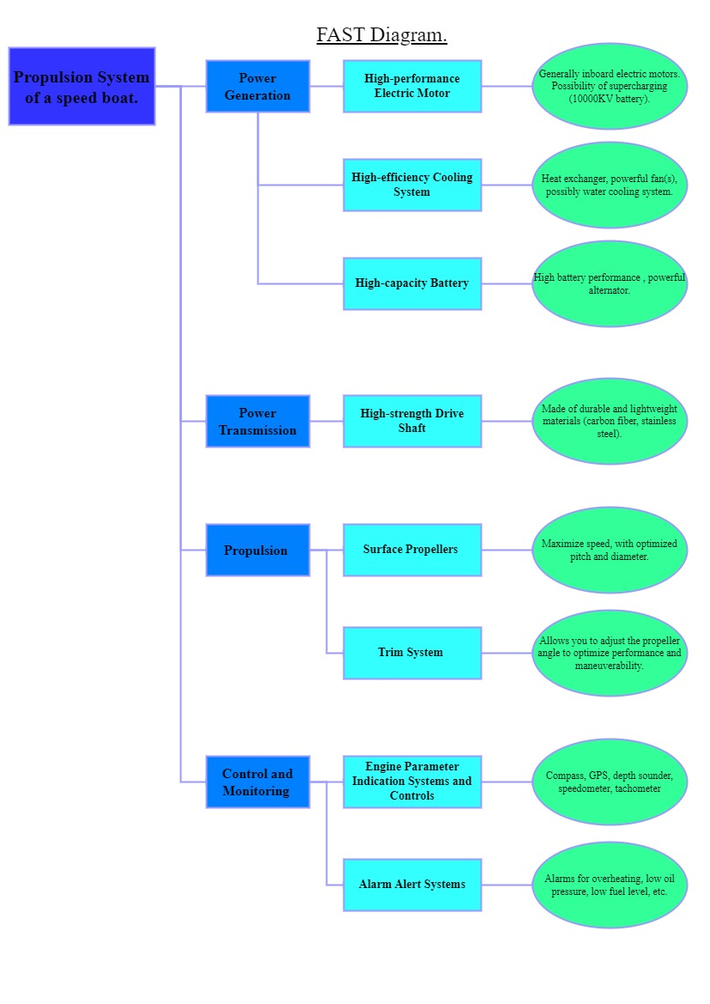

1. SADT diagram.

The SADT (Structured Analysis and Design Technique) diagram is another functional analysis tool that allows us to graphically represent the different stages of the propulsion boat design process. Using this diagram, we will be able to identify the functions, information flows and constraints of the system, which will give us a detailed view of how it works.

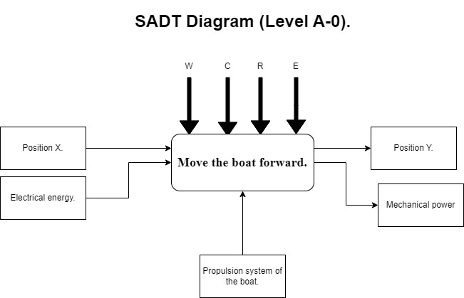

Where;

W: Electrical energy.

C: Must be mounted co-axially (One axis).

R: Regulate the speed of the motors.

E: Monitor by a command, On/Off.

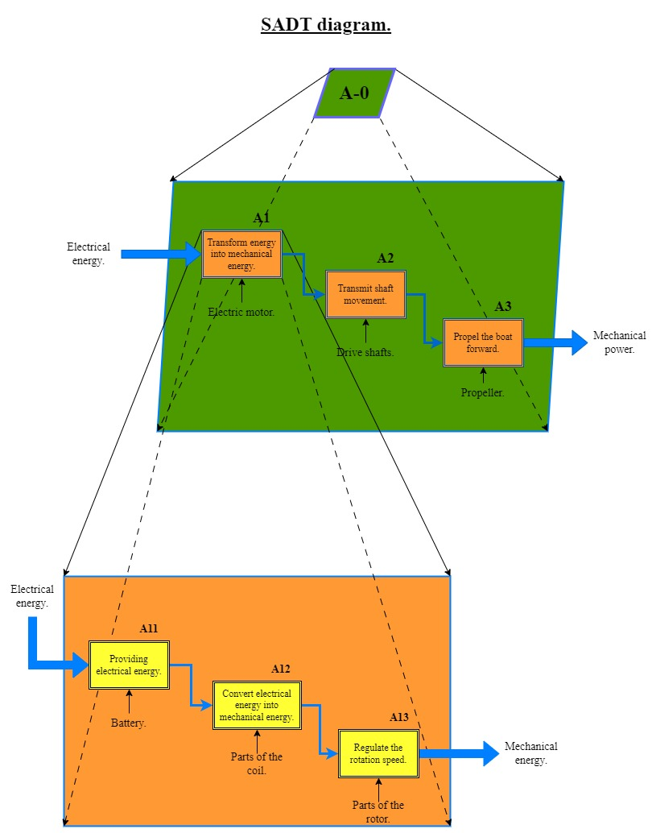

1. **Functional workbook**

As a customer or company looking for a propulsion system for a boat, we have identified several key functions that we wish to integrate into our functional specifications. Each feature helps ensure optimal performance, increased security, and overall satisfactory functionality. Here are the detailed specifications for each function:

* Allow the user to move the boat hull forward efficiently and reliably.
* Maintain an affordable price for the propulsion system, with a target range of $500 ± $50.
* Ensure compliance of the propulsion system with environmental standards to reduce the impact on the environment.
* Optimize system weight and dimensions to meet hull performance and manoeuvrability requirements.
* Generate sufficient power to effectively propel the hull, overcoming water resistance.
* Use an appropriate electrical energy source, compatible with the needs of the propulsion system.
* Integrate reliable safety features to ensure the safety of the boat and its occupants.

By meeting these functional specifications, we aim to obtain a propulsion system that meets our expectations in terms of performance, safety and overall functionality. We look forward to your detailed proposal, demonstrating how your solution meets the requirements set out in this functional specification.

1. **Choice of the transmission elements**

* **Shaft transmission**

|  |  |  |
| --- | --- | --- |
|  | Advantages | Disadvantages |
| Gear transmission | * high transmission efficiency * precision and reliability * ability to withstand heavy loads * low slip * transmits large amounts of power | * Noisy (does not absorb shocks and vibrations) * Requires proper lubrication * high cost * difficult to change speed |
| Pulley-belt transmission | * Economical * silent, absorbing shock and vibration * can transmit large amounts of power | * slippage * frequent wear * regular maintenance and less precision than gears |
| Transmission with coupling | * smooth torque transmission * compensation for shaft misalignment * compact design | * has no power transmission capacity of its own * requires an additional transmission element to operate |
| chain drive | * can transmit large amounts of power * ability to withstand heavy loads * long service life * can be used at high speeds | * noisy * slippage * proper lubrication * can cause tooth abrasion |
| drive shaft | * efficient, robust direct drive * can be used over long distances | * cannot compensate for alignment errors * high cost * Requires precise alignment of both shaft ends |

* **Multi-criteria matrix**

To make a clearer, more objective choice of power transmission unit, we'll use a multi-criteria analysis tool based on the following criteria:

* power: the most important data when choosing a drive unit
* transmission efficiency: indicates the percentage of power transmitted without loss
* precision: indicates transmission stability in terms of accuracy and repeatability
* slippage: indicates the degree of slippage between gears or contact surfaces
* Shock and vibration absorption: indicates the drive unit's ability to absorb shock and vibration.
* Maintenance: indicates the level of maintenance required for the drive unit
* Durability: indicates the useful life of the drive unit under normal conditions of use.
* Load capacity: indicates the capacity of the drive unit to support the maximum load required
* Overall dimensions: indicates the space required to install the drive unit

This table enables us to evaluate the various criteria mentioned, assigning them a weighting with a maximum score of 10.

|  |  |  |  |  |  |
| --- | --- | --- | --- | --- | --- |
| **choice criteria** | **Gear** | **Belt** | **chain** | **coupling** | **drive shaft** |
| **Power** | 9 | 7 | 8 | 6 | 10 |
| **Transmission efficiency** | 8 | 7 | 9 | 6 | 10 |
| **Accuracy** | 7 | 5 | 6 | 9 | 10 |
| **Slides** | 6 | 8 | 7 | 9 | 5 |
| **Choc and vibrations absorption** | 5 | 6 | 7 | 9 | 8 |
| **Maintenance** | 4 | 8 | 6 | 9 | 5 |
| **Durability** | 9 | 7 | 8 | 6 | 10 |
| **Load capacity** | 9 | 7 | 8 | 6 | 10 |
| **footprint** | 6 | 8 | 7 | 9 | 5 |
| **Cost** | 4 | 8 | 10 | 10 | 2 |
| **TOTAL** | 63 | 63 | 66 | 69 | 73 |

After analysing this table, we can see that the driveshaft got the highest score, so it will be our choice. In terms of criteria, although it's bulky, it meets our needs better than other transmission components, as it offers high power, efficient transmission, greater precision, load capacity and durability. However, to optimize the efficiency and performance of our boat, we can combine the coupling with our driveshaft.

* **Coupling type choice**

|  |  |  |
| --- | --- | --- |
| **coupling** | **Advantages** | **disadvantages** |
| **Stiff coupling** | * Efficient power transmission * reliability * durability | * Cannot compensate for major misalignments * Can cause vibration in case of misalignment |
| **Semi-elastic** | * compensate for minor misalignments * Reduce vibrations | * Not very tolerant of large misalignments * may require periodic replacement |
| **Elastic** | * Are able to compensate for large misalignments * Reduce vibrations | * Limited-service life due to wear of elastic elements |
| **OLDHAM joint** | * transmit power between two non-aligned shafts * compensate for large angular misalignments * reduce vibration | * cannot compensate for large axial misalignment errors |
| **Cardan joint** | * transmit power across angles * compensate for minor misalignment | * not suitable for high-precision applications * may require regular maintenance |

|  |  |  |  |  |  |
| --- | --- | --- | --- | --- | --- |
| **Characteristic** | **Rigid couplings** | **Semi-elastic couplings** | **Elastic couplings** | **Oldham joint** | **Cardan joint** |
| **Rigidness** | 100 | 75 | 50 | 25 | 50 |
| **Vibration absorption** | 0 | 50 | 75 | 90 | 50 |
| **Tolerance to misalignment** | 0 | 50 | 50 | 90 | 25 |
| **Precision** | 100 | 75 | 50 | 100 | 75 |
| **Cost** | 75 | 75 | 75 | 75 | 75 |

Given our desire to have the same power output from our drive unit, we chose to associate the cardan joint with our drive unit because of its accessibility on the campus and the Cardan joint is a compromise between rigidity, precision, and misalignment tolerance.

* **Motor type choice**

After calculation, our boat will need an effective power of 100 W. Therefore, we chose a DC motor of voltage 12V with a number of revolutions per minute of 12000 RPM and 1000KV.

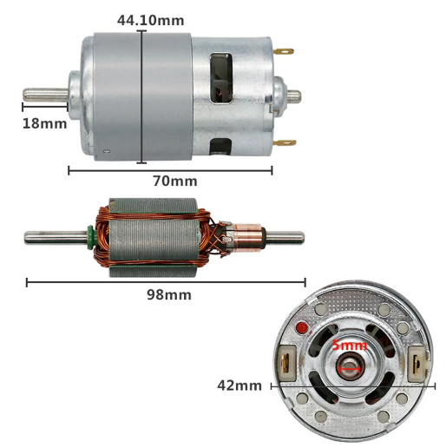

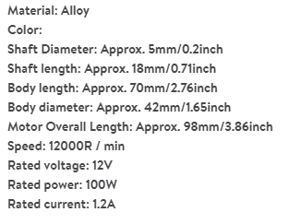

1. **STUDY OF THE BOAT'S POWER TRANSMISSION SYSTEM**
2. **Définition**

A control transmission component in a vessel could be a gadget that exchanges power from the motor to other components within the watercraft, such as the propeller or impetus framework. They at that point frame the control transmission framework that impels the pontoon. In a vessel, in any case, there are three categories of control transmission components:  
electrical, mechanical and electronic, but since we're talking almost mechanical control transmission, we're progressing to centre basically on mechanical control transmission.

SKETCH OF MY BOAT

Motor

Shaft transmission unit

Propeller

1. **Power transmission system components**

The power transmission system includes the following components:

* The electric engine: this can be the boat's primary source of control. It is fuelled by the battery, which stores the essential vitality;
* The speed controller: this controls the sum of vitality provided to the engine, hence too controlling its speed;
* Transmission: this transmits the mechanical control produced by the electric engine to the propeller. It may comprise of a shaft, gears, belts or other components;
* The propeller: this changes the mechanical control transmitted into hydrodynamic pushed, impelling the vessel through the water. CAD OF MY BOAT

Transmission

Helicene

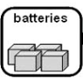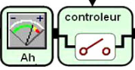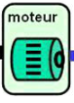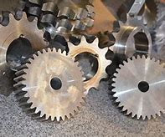

*Ener. Elec.*

*Ener. Mec.*

***Pe, We***

***Ps, Ws***

1. **Study of the stretch exerted on the system**

A boat's power transmission unit, usually a propeller shaft, is subject to several major stresses, the main ones being:

* **Mechanical stretch:** The shaft must be able to resist the powers and minutes created by the propeller, engine and transmission components (e.g. gearbox) without distorting or breaking.
* **Torsion**: twisting force that is applied to the shaft by the engine or motor.
* **Bending**: the force that tends to bend the shaft, due to the weight of the propeller and the forces exerted by the water as the boat moves.
* **Axial thrust**: force that tends to push the shaft forward, due to the thrust of the propeller.
* **Thermal stresses**: due to grinding and the stack applied on the shaft, it can warm up impressively. It must subsequently be outlined to resist all temperatures without losing its mechanical properties.

**IV. SIZING OF POWER TRANSMISSION COMPONENTS**

1. **Transmission line sizing**
2. **Organ description**

On vessels fitted with an inboard engine, control is transmitted from the engine to the propeller by means of a shaft that passes through the body to turn the propeller.

The association between the engine and propeller must subsequently be watertight, able to resist the torque of the engine and retain the vibrations of the inboard engine, for ideal propeller effectiveness and cruising consolation. The number of the propeller can influence the manoeuvrability and stability of the boat. This number will be a matter of compromise:

|  |  |  |  |  |
| --- | --- | --- | --- | --- |
| Number of blades | speed | thrust | efficiency | cost |
| two | excellent |  | excellent | low |
| three |  | better | good | low |
| four | Good | Good | good | average |
| five |  | good | low | high |

* A two-blade provides excellent speed performance.
* A three-bladed blade (the most common) offers the best speed/thrust compromise
* A four-blade will be better balanced and quieter with a thrust orientation
* A 5-blade dedicated to thrust

So, for our boat, we will choose the Four blade because it is the only one that offers the best speed/thrust compromise and the high efficiency.

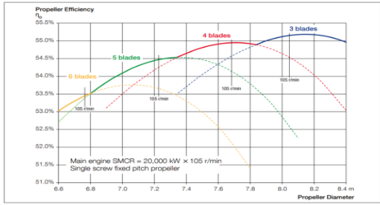

1. **Sizing**

* **diameter calculation**

**High-power 775 Motor DC 12V 12000rpm Large Bearing Tools**

**Efficiency of the motor:**

**Pe: electric power**

**Pm: mechanical power**

|  |  |  |
| --- | --- | --- |
| **Shaft calculation** | | |
| **diameter** | $$∅≥ {\left[\sqrt{\frac{16×M_{t}}{π×δ_{adm}}}\right]}^{1/3}$$ | $$d≥0.33mm$$ fixed d= 6.35 mm |
| **Length** | **arbitrary** | **L= 300 mm** |
| **Propeller calculation** | | |
| **external diameter** | $$D=12500\sqrt[4]{\frac{P}{(Vmax*Nt^{2})}}$$ | $$D=64.6mm$$ |
| **internal diameter** |  | $$d_{p}=6.35mm$$ |
| **pitch** | $$Pitch =2.48*D*V/P^{0.186}/N^{0.374}$$ | $$Pitch=113.9 mm$$ |
| **propeller efficiency** | $$Rdmt= 0,350 + 0,561 Y + 0,018 Y^{2} - 0191 Y^{3} - 0,013 Y^{4}$$ | $$Rdmt=0.724$$ |
| **propeller power** | $$Rdmt=Ph/P ⇒Ph=Rdmt*P$$ | $$Ph=0.724*100=72.4 W$$ |
| **Thrust** | $$Thrust = max(Rtotal)/(1-t)$$ | $$Thrust =29.7 N$$ |

$$η=\frac{Pm}{Pe}⇒ η=\frac{108.6}{100}=0.73$$

* **diameter calculation**

$P=100 W; N=12000 trs/min=200 trs/s$**;**

* P: power
* Nt: number of revolutions per minutes

$$⇒M_{t}=F×L=1.03 ×0.3=0.3084 Nm$$

$$⇒M_{f}=\left\|bc\right\|\sqrt{{(X_{c})}^{2}+{(Y_{c})}^{2}}=\left\|0.15\right\|\sqrt{{(0)}^{2}+{(0.524)}^{2}}=0.0786 Nm$$

$$⇒δ_{adm}=\frac{Limite d'elasticite}{Facteur de secutite}=\frac{222}{2.0}=111 MPa$$

$$AN :∅≥ {\left[\frac{16}{π×δ_{adm}}\sqrt{4{\left(M_{f}\right)}^{2}+3{\left(M_{t}\right)}^{2}}\right]}^{\frac{1}{3}}=2.9 mm$$

Our minimum diameter is 2.9mm, and we're going to use a 6.35mm diameter because that's the diameter of our rotor.

**2. Propeller sizing**

The propeller is an essential element of the propulsion of the boat. It transforms the motive energy provided by the engine into a propulsive force which pushes the boat forward.

* **diameter calculation (external and internal)**
* **External**

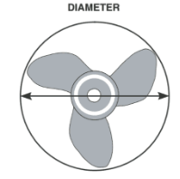

$D=12500\sqrt[4]{\frac{P}{Vmax×Nt^{2}}}= 12500\sqrt[4]{\frac{0.150}{0.5 ×12000^{2}} }$ $⇒D=64.6mm$

$$Where P(Kw)=0.100;N(RPM)$$

* **Internal**

Since the propeller fits onto the transmission shaft by means of the key, its diameter must be equal to that of the transmission shaft.

So $d_{s}=D_{p}=6.35 mm$

* **surface calculation**

$Ao=π*\frac{D^{2}}{4}$ $⇒Ao=3.14×\frac{64.60^{2}}{4}=3275.9 mm^{2}$

* **Propeller pitch calculation**
* **propeller efficiency calculation**

$Y=1,33.log(Pitch/D) + 0,71$

$⇒Y= 1.33*log(\frac{26.155}{47.71})+0.71=0.362$

$Rdmt= 0,350 + 0,561 Y + 0,018 Y^{2} - 0191 Y^{3} - 0,013 Y^{4}$ $⇒Rdmt=0.724$

* **propeller power calculation**

$$Rdmt=Ph/P ⇒Ph=Rdmt*P$$

$$⇒Ph=0.724*100=72.4 W$$

1. **Sealing system**

**Analysis of components likely to meet sealing needs**

A boat is said to be watertight when it has no interaction with the water. Thus, to make a boat completely watertight, a watertightness system must be put in place. This system essentially applies to the hull of the boat and the system transmission.

|  |  |  |  |  |
| --- | --- | --- | --- | --- |
| Part of the boat | Technique | Description | Benefits | Disadvantages |
| Hull (Aluminium) | Cover with epoxy resin | Applied to bare shell to protect against moisture | Excellent adhesion and sealing | Requires precise preparation and mixing |
|  | marine adhesive |  | Excellent adhesion to various materials and surfaces | -Difficult to remove -May leave sticky residue  - May degrade in the presence of certain chemicals |
| transmission system | Protective sleeve |  | - Effectively protects the seal against splashing water | - May add additional friction or vibration |
|  | Gasket |  | - Provides a tight barrier between transmission elements | Requires regular inspection for signs of wear or deterioration |
|  | Colle |  | Easy to apply and use | - Requires periodic reapplication  - Less resistant to moisture and solvents than other options |
|  | Waterproof electrical tape |  | - Easy to apply and remove | - Requires periodic replacement |

Waterproofing is usually insured by construction products (such as membranes) or materials (such as coatings) that are waterproof and insensitive to humidity.

In the case of boats, there are several techniques for sealing the hull of the boat which is the main part of the boat.

1. Reinforcements.

|  |  |  |  |
| --- | --- | --- | --- |
| Number | Length of the first side (L1) in mm | Length of the second side (L2) in mm | Mass (g) |
| 1 | 19.45 | 33.60 | 5.269 |
| 2 | 52.46 | 62.30 | 11.385 |
| 3 | 73.91 | 79.60 | 15.224 |
| 4 | 85.87 | 88.62 | 17.292 |
| 5 | 91.15 | 91.96 | 18.139 |
| 6 | 92.20 | 91.83 | 18.227 |
| 7 | 90.53 | 89.34 | 17.809 |
| 8 | 87.02 | 85.29 | 17.061 |

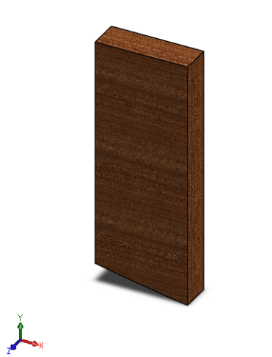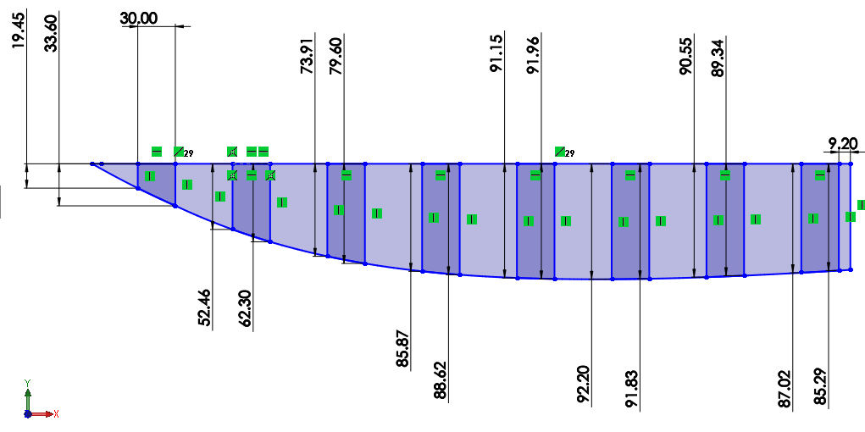

Figure 2: Exemple of a renforcement.

Length of the first side (L1).

Length of the second side (L2).

Figure 1: Reinforcement sketches.

# Calculations:

## 1.1 Reinforcers;

$$⟹Total mass of reinforcers= 0.120406 ×2=0.240812 Kg$$

$⟹Reinforcers weight=mass ×gravitational force=0.445×9.81=2.36236572 N$

$$⟹New weight=Current weight+Reinforcers weight=1.762+0.445≈2.207 N$$

## 1.2 New Draft (T);

$$C_{B}=\frac{∇}{B × L_{WL} × T}$$

$$⇒T= \frac{∇}{B × L_{WL} × C_{B}}$$

$= \frac{0.0028}{0.1625 ×0.564 ×0.5456}=$ = $0.056 m.$

## 1.3 Thickness(e);

Where;

e = Thickness of the hull.

$P_{s}$ = Static pressure.

$P_{c}$ = Kinetic pressure.

$P$ = Sum of pressures. ($P_{s}+P_{c})$

$σ$ = Oostreveld formulation.

$L$ = Space between reinforcer.

Epaisseur(e) $=0.77 × L × \sqrt{P/σ}$

$⟹$ Pressure of water.

10, 000 Pa 1m

? Mpa T = 0.056m

X Mpa $= \frac{10000×0.056}{1}=560 Pa.$

OR

$⟹$ Kinetic pressure.

$$P_{c}= \frac{F}{S}= \frac{1}{2}×\frac{C_{A}×ρ× v^{2}×S}{S}= \frac{1}{2}×C_{A}×ρ× v^{2}$$

$$= \frac{1}{2}×0.000819×1025× 0.25$$

$$=0.105 Pa.$$

$⟹$ P = $560+1.68=560.105$ Pa

$⇒σ=60\%×$ Elasticity limit.

$= \frac{60 }{100}×2.28×{10}^{6}=1.368 MPa$.

$$⇒ L=61.25 mm$$

$⇒$ Thickness $=0.77 × L × \sqrt{P/σ}=0.77×61.25×\sqrt{\frac{560}{1,368,000}}=0.95 mm.$

## 1.4 Comparative table;

|  |  |  |  |  |
| --- | --- | --- | --- | --- |
|  | | | **Numerical values.** | |
| **No** | **Criteria** | **Symbols** | **1 st semester.** | **2nd semester.** |
|  | Mass of the boat | m | 2.352 Kg | 3.482 Kg |
|  | Length between perpendiculars | $$L_{PP}$$ | $$0.650 m$$ | $$0.650 m$$ |
|  | Length on waterline | $$L_{WL}$$ | 0.480 m | 0.600 m |
|  | Breadth | $$B$$ | $$0.1625 m$$ | $$0.1625 m$$ |
|  | Draft | $$T$$ | $$0.048 m$$ | 0.056 m |
|  | Freeboard | $$F$$ | $$0.052 m$$ | 0.040 m |
|  | Volume displacement | $$∇$$ | $$0.002352 m^{3}$$ | $$0.003482 m^{3}$$ |
|  | Boat displacement | $$∆$$ | $$23.53 N$$ | $$34.82 N$$ |
|  | Density of water. | $$ρ$$ | $$1025Kgm^{3}$$ | $$1025Kgm^{3}$$ |
|  | Ship speed | $$V^{2}$$ | $$9{ m}^{2}s^{-2}$$ | $$9{ m}^{2}s^{-2}$$ |
|  | Cross-sectional area of the hull | $$S$$ | 0.0880 $m^{2}$ | 0.1168 $m^{2}$ |
|  | Shape coefficient | $$C_{A}$$ | 0.00081958 | 0.00081903 |
|  | Prismatic coefficient | $$C_{P}$$ | 0.6479 | 0.6203 |
|  | Midship coefficient | $$C_{M}$$ | 0.9696 | 0.9595 |
|  | Block coefficient | $$C_{B}$$ | 0.6282 | 0.5952 |
|  | Waterplane area coefficient | $$C_{WP}$$ | 0.7538 | 0.7327 |
|  | Frictional coefficient | $$C_{F}$$ | 0.0045 | 0.0043 |
|  | Numerical constant | $$c_{1}$$ | 17.5458 | 17.4230 |
|  | Numerical constant | $$c_{2}$$ | 1 | 1 |
|  | Numerical constant | $$c_{3}$$ | 0 | 0 |
|  | Numerical constant | $$c_{4}$$ | 0.04 | 0.04 |
|  | Numerical constant | $$c_{5}$$ | 1 | 1 |
|  | Numerical constant | $$c_{7}$$ | 0.3385 | 0.2708 |
|  | Numerical constant | $$c_{15}$$ | -1.6939 | -1.6939 |
|  | Numerical constant | $$c_{16}$$ | 1.3133 | 1.3431 |
|  | Angle of the waterline at the bow | $$i_{E}$$ | 37.9317 $°$ | 25.3375 $°$ |
|  | Numerical constant | $$m_{1}$$ | -3.2812 | -2.9436 |
|  | Numerical constant | $$m_{2}$$ | -0.6748 | -0.6105 |
|  | Froude number | $$F_{n}$$ | 1.3821 | 1.2362 |
|  | Numerical constant | $$d$$ | -0.9 | -0.9 |
|  | Wave-making and wave-breaking resistance | $$R_{W}$$ | 0.0270 KN | 0.0315 KN |
|  | Frictional resistance according to the ITTC-1957 friction formula | $$R_{F}$$ | 0.0018 KN | 0.0023 KN |
|  | Model-ship correlation resistance. | $$R_{A}$$ | 0.00033 KN | 0.00044 KN |
|  | Total Resistance | $$R_{Total}$$ | 0.0279 KN | 0.0315 KN |

**VI. CAO DES ORGANES**

